American New wave Foods LLC IMPORTED SWINE GENETICS & PRODUCER PARTNERSHIPS

Build a Swine Enterprise That Fits Your Farm
  - Proven genetics. Practical systems. Production support.
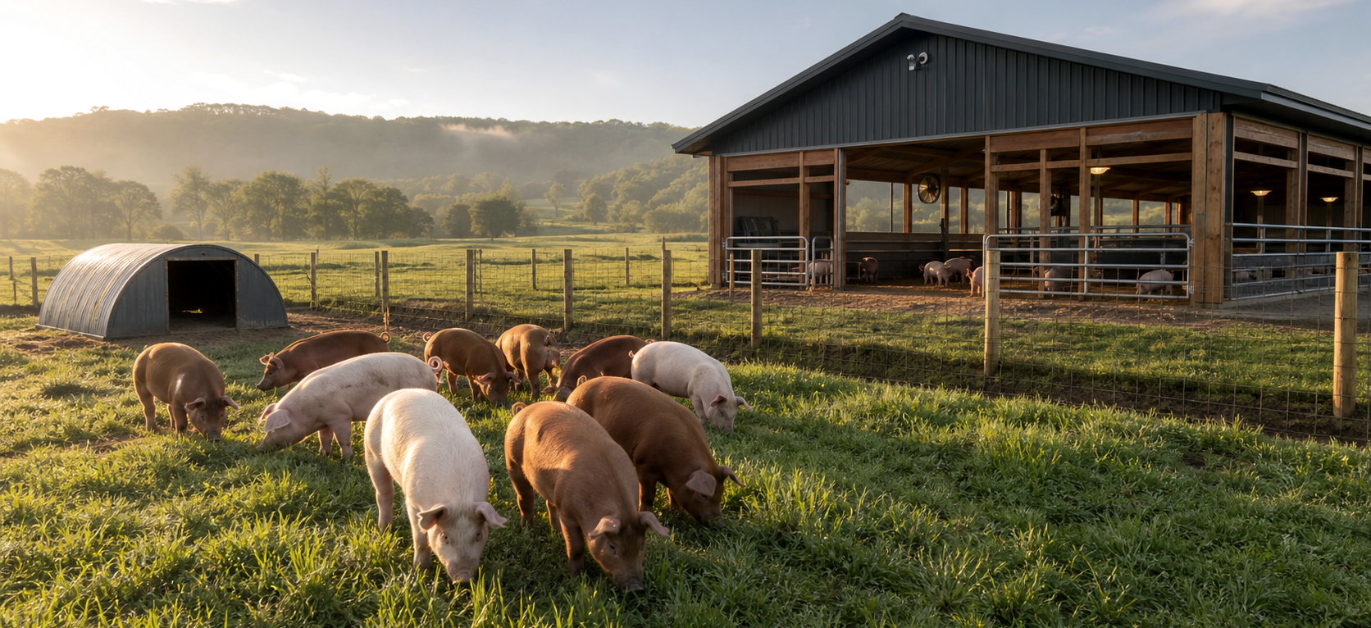
TAILORED PRODUCTION, BUILT AROUND YOUR RESOURCES
ANWF can design a low-cost outdoor, efficient indoor, or flexible hybrid system around your facilities, available capital, labor, feed access, production capacity, climate, and target market.

PRACTICAL FARM DESIGN

Choose the production style that makes sense for your operation.
LOW-COST OUTDOOR  Pasture and paddock layouts, portable or hoop shelters, fencing, watering, feeding, and handling flow designed for a practical entry cost. | EFFICIENT INDOOR  Barn and pen layouts, ventilation, sanitation, and animal movement plans that can use existing structures when feasible to help control investment. | FLEXIBLE HYBRID  Combine sheltered stages with outdoor production. The plan is tailored to climate, land, labor, feed access, capacity, and target market.

GENETICS ARE THE STARTING POINT. The ANWF offer can also include guidance for facilities, breeding, feeding, herd health, and production flow.

START WITH THE RIGHT GENETICS

Choose Your Starting Package
Select a package, then tailor the production plan and level of ANWF support to the farm.
PACKAGE | WHAT'S INCLUDED | PRICE
5-Gilt Starter | 5 commercial replacement gilts + breeding/semen program | $2,730 + delivery
10-Gilt Farm | 10 commercial replacement gilts + breeding program | $5,360 + delivery
20-Gilt Commercial | 20 commercial replacement gilts + breeding program | $10,470 + delivery
10 Gilts + Registered Duroc Boar | 10 commercial replacement gilts + 1 registered Duroc boar | $5,995 + delivery

INDIVIDUAL GENETICS Commercial replacement gilt: $450/head | Duroc semen: $18/dose | Typical breeding unit: 2 doses / $36 | Registered Duroc boar: starting at $1,200

THREE WAYS TO WORK WITH ANWF

Choose Your Producer Relationship
1 INDEPENDENT GENETICS  Purchase ANWF genetics and operate independently. You own the pigs, choose your market, and can receive breeding and production guidance. | 2 MARKET PARTNER  ANWF receives a conditional first opportunity to purchase qualifying 60-80 lb feeder pigs, subject to specifications, records, batch size, scheduling, market capacity, and agreed pricing. | 3 INTEGRATED GROWER  A customized production agreement can coordinate genetics, feed, veterinary program, SOPs, production standards, and marketing. Compensation follows the signed agreement.

MORE THAN BREEDING STOCK Start a feeder-pig production unit with proven genetics, practical production protocols, and a market pathway matched to your goals.

READY TO BUILD YOUR PLAN? Ask ANWF to evaluate your farm resources, recommend a genetics package, and scope a tailored outdoor, indoor, or hybrid production system.
Prices and animal availability are subject to change; delivery is additional. Market-partner purchases are conditional and are not guaranteed. Final terms, specifications, scheduling, and compensation must be documented in the applicable agreement.

